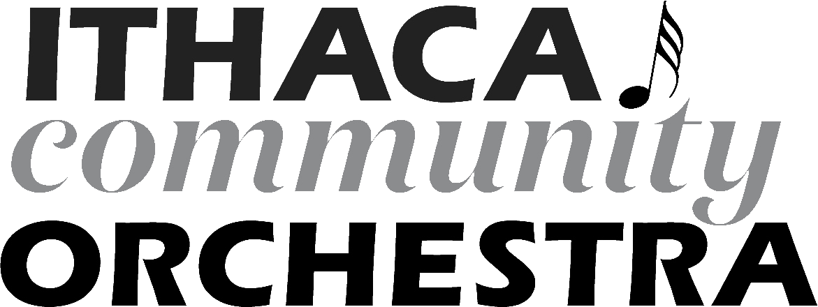 | Ithaca Community Orchestra, Inc.  P.O. Box 6787  Ithaca, NY 14851  www.ithacacommunityorchestra.org  Federal Tax ID: 26-1860192

Advertiser:
Contact Name:
Address:
Phone:
E-mail:
Date:

Please select ad size:
□ Half page vertical: 10”x3.75” $300
□ Half page horizontal: 5”x7.5” $300
□ Quarter page: 5”x3.75” $150
□ Quarter page: 10”x1.875” $150
□ Four squares block: 2”x3.75” $60
□ Four squares vertical: 4”x1.875” $60
□ Three squares vertical: 3”x1.875” $45
□ Two squares vertical: 2”x1.875” $30
□ Two squares horizontal: 1”x3.75” $30
□ One square: 1”x1.875” $15

Your ad will appear in the programs for the Ithaca Community Orchestra concerts in Fall 2022 and Spring 2023. Please remit payment to address above. Please send your black and white ad in .jpg format to juliatphillips@yahoo.com. Ads must be received no later than October 8, 2022.

Thank you for supporting the Ithaca Community Orchestra!

